6.13: Let point 1 be at the bottom of the incline and let point 2 be at the skier.
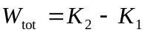
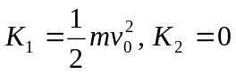
Work is done by gravity and friction, so 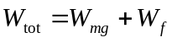.
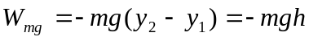
Substituting these expressions into the work-energy theorem and solving for  gives
